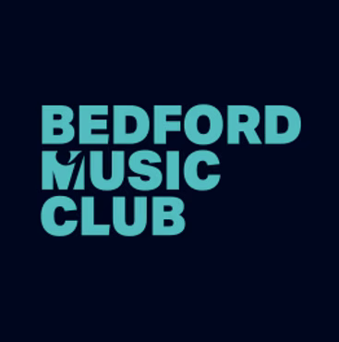
Bach 1726: Life and Death

Orgelbüchlein Project for Young Organists, April 8th & 11th
Application Form

Name:
Date of Birth:
Email:
Mobile (optional):

Place of Study & brief biography:

Describe how you would go about exploring the festival themes, and suggest why this project appeals to you (max 200 words):

Please confirm that you are available for both the study sessions (April 8th), and the day of recitals (April 11th) in Bedford.
Attach your two proposed programmes to this cover sheet. For full details, see the application pack.

